Hot Topic :-

Game for kids to aware about Misuse of electricity and its after effect.

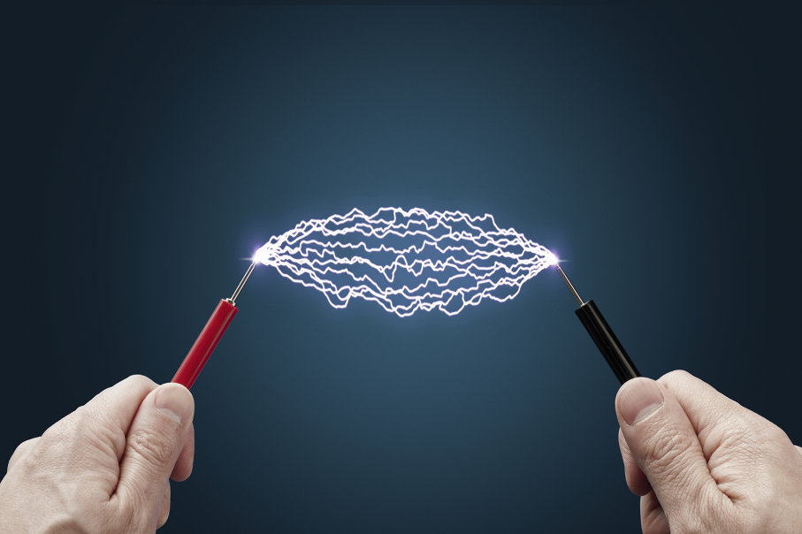

**Proposed by,**

**Fadi Fayez**

**Submitted by**

**Binby Babu - 170009247**

**Nithin Prasannakumar - 170010953**

# Who did what?

|  |  |
| --- | --- |
| BINBY BABU   * + Introduction   + Resources   + Project risk   + Project Planning   + Gantt Chart   + References | NITHIN PRASANNAKUMAR   * + Software and research methodology   + Existing System and Other Applications   + Existing Applications: Pros and Cons   + Conclusions |

**Contents**

**1.** **Introduction** 5

**1.2 Research Questions and solution** 5

**1.3 Issues** 5

**1.4 Aim and Objectives** 6

**1.5** **Measurable Organisational Value (MOV)** 6

**2.** **Existing System and other Applications** 7

**2.1 Current Games and application** 7

**2.1.1 Toddler & Baby Games** 7

**2.1.2** **Masha and the Bear: Goodnight** 9

**2.1.3** **Baby Puzzles** 12

**2.1.4** **Safety for Kid** 14

**2.1.5** **Kids Road Safety Guide: Street walking training** 16

**2.2 Existing Applications: prons and oncs** 18

**3. Software and Research Methodology 19**

**3.1 Spiral Technology** 19

**4.** **Resources** 20

**4.1 Android Studio** 20

**4.2 Unity** 21

**4.3 Java- Eclipse** 22

**5.** **Project Risk** 23

**5.1 Schedule Risk and Time Management** 23

**5.2 Performance Risk** 24

**5.3 Scope Risk** 24

**5.4 Communicational Risk** 24

**5.5 Hardware and Software Failure** 24

**6.** **Project Planning** 24

**6.1** **Responsibilities** 24

**7.** **Gantt chart** 26

**8.** **Conclusion** 26

**9.** **References** 27

# List of Figures

Fig 1: T&B Screenshot1 7

Fig 2: T&B Screenshot2 8

Fig 3: T&B Screenshot3 9

Fig 4: M&B Screenshot1 10

Fig 5: M&B Screenshot2 11

Fig 6: M&B Screenshot3 11

Fig 7: M&B Screenshot4 12

Fig 8: Baby Puzzles Image1 13

Fig 9: Baby Puzzles Image2 13

Fig 10: Baby Puzzles Image3 14

Fig 11: Baby Puzzles Image4 14

Fig 12: SafetyForKid 1 16

Fig 13: SafetyForKid 2 16

Fig 14: SafetyForKid 3 16

Fig 15: KidsRoadSafety1 17

Fig 16: KidsRoadSafety2 18

Fig 17: KidsRoadSafety3 18

Fig 18: Android Studio 20

Fig 19: Unity 21

Fig 20: Eclipse 22

Fig 21: Gantt chart 26

# 1. Introduction

Electricity is one of the most commonly used forms of energy by mankind. When we take modern technologies, electricity is the heart of all creations. (Electricity, 2018). Electricity can be generated through different methods. In New Zealand electricity is produced through hydroelectric method, by the use of water. (Electricity Authority, n.d). Even though electric power is the most using energy power by humanity, and also working with that can be dangerous. When an electric current pass through the human body it undergo some body trauma and sometimes affect the internal organs and may result in death. (Healthy safe and productive lives, n.d). Electrical injuries are mainly occurred due to unawareness of electrical danger, carelessness, and lack of proper guidance about electrical injuries. Now most of the people have awareness about electrical issue. But, the kids below 6 years have less knowledge about electricity and their after effects. If we try them to explain the power issues theoretically, the output will be less. That’s why we planned to create an interactive game, through that, they will get an idea about power energy issues and it helps them to understand more about electrical misuse and their results.

## 1.2 Research Questions and solution

This project deals to get understanding about electrical misuse and their consequences for kids below 6 years and make it interactive through an android game application which is more reachable for kids. This application is recommended to give an answer for the below question. Can a mobile game application helps to improve awareness about misuse of electricity and their after effects?

## 1.3 Issues

The most important requirement of current day economy is the electrical energy and without which the working of society will suffer and shade of public life will be reduced. Earlier, the peoples are not mostly depends on electrical energy so that they can manage their lives without that. But currently, the situation reversed and the humans are fully depends on energy. Due to that the wastage of power is also increased and the disaster due to that also increased. (Huwaida, 2018). Majority of citizens are vigilant about energy crisis but it displays only one part of a coin. Others have less knowledge about it. (Karachi, 2012). If we give proper tutorial for them, and they will get an idea and the energy misuse can be reduced. But On the other hand, we have to think about our kids below 6 years and our future generation. If we give a proper guidance about energy misuse and disaster from the starting of their life then they will not forget in their life. It will reduce electrical misuse and dangers. Electrical energy is being misused and wasted at institutions, homes, restaurants, malls, playground etc. The different types of hazards due to electrical energy for kids below 6 years age are: They will put fingers in outlet, touch the plug of cord surrounded by water, climb on power poles, fly kites close to power lines, and go near to fallen power cables, climb trees near to power lines etc. (BC hydro power smart, n.d). If we try to give the tutorials in academic way, it’s very hard to hit in their mind. However if we give lessons through any mobile applications or games, it will stay in their mind and they get aware about the power of electricity, usage, danger, etc.

## 1.4 Aim and Objectives

The aim of our project is very important, is to create a Mobile game application for kids between four to six years of age and to create awareness about misuse of electricity and their after effects. Due which we can offer a colourful entertainment world to the kids in the form of game and also educate them about electricity. Presently young children are using mobile applications and games very frequently. Due to that the impact of mobile device on development and learning of kids changed a lot. So, if we create a game about electrical hazards, and it will paste into their mind and help that thing in their future life and the power misuse can be reduced. This game application will be a user friendly one and will have an easy navigation and we are using simple interface so it’s very easy for kids to play.

## 1.5 Measurable Organizational Value (MOV)

The Measurable Organisational Value of this project is focused in the direction of the social aspects of kids between four to six years of age to give alert about energy threats and misuse. Current kids are the future of New Zealand, and if they have the aware about power energy misuse, then it will create a positive impact in future and it automatically affects the positive growth of country and world. This gaming application will allow them to recognize the hazards and it will help them to eliminate these hazards in future for the safety of other peoples. Due to this gaming application, the hazards caused to electrical equipment shall be reduced.

# 2 EXISTING SYSTEM AND OTHER APPLICATIONS

## 2.1 Current Games and applications

The research was done for the existing applications or games that created awareness amongst the kids, about the misuse and risks in electricity. A few applications were similar to that of our proposal but were entirely different from our objectives. There were applications which gave ample resources of electricity misuse and its dangers, but there were no games on the same base. We came across various games to come up with an idea. The following are the list of games that we referred:

* Toddler & Baby Games
* MaB Goodnight
* Baby Puzzles
* Kids Road Safety Guide: Street walking training
* Safety for Kid

### Toddler & Baby Games (EduJoy, 2018)

This is one of the most efficient games, which is predominantly used by the teachers and parents to improve the educational process of the kids. This games helps the kids to improve their learning and intellectual skills. This game is designed for the kids under the age 8 years and above 3 years.

There are various games inside this game.

* COUNT AND MATCH: This game improves the kids to understand numbers and counting.
* SORT IT OUT: To improve the child’s arranging and sorting, hence improving their imagination power.
* WHAT’S DIFFERENT: Spot the odd one out has always been an enthusiastic game among the kids, developing their skills in finding the difference and hence creates a cast level of curiosity.
* MATCH IT UP: This is to identify the similar objects. This is a drag and drop game.
* FAMILIES: This section helps the kids to identify and name of the family members (e.g. Niece, Nephew, Uncle, etc.)
* PUZZLE: An amateur level puzzle game for the kids, with a colorful background.
* MEMO GAME: This game increases the standards of the child’s brainstorming skills.
* COMPLETE THE SERIES: This series is a combination of various items like shapes, color, size and quantity, hence teaching your kids to learn how to complete a series.
* MY PROFESSION: This gives an idea about the different jobs in this world.
* MOSAIC GAME: Increases the hand eye coordination and the visual perception of the kids. It also increases the accuracy, perseverance and diligence.

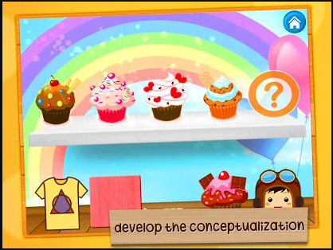

Fig 1 T&B Screenshot1

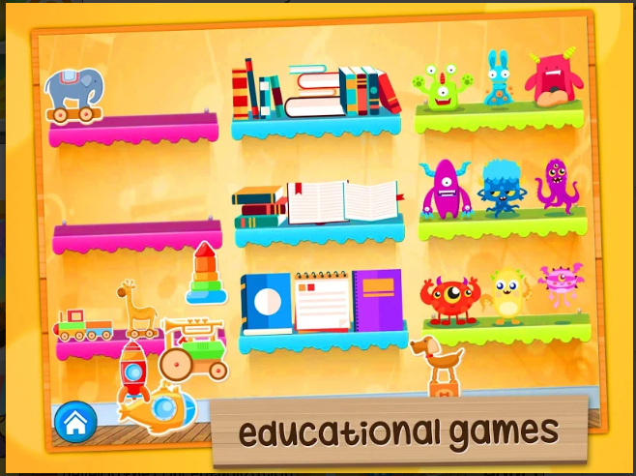

Fig 2 T&B Screenshot2

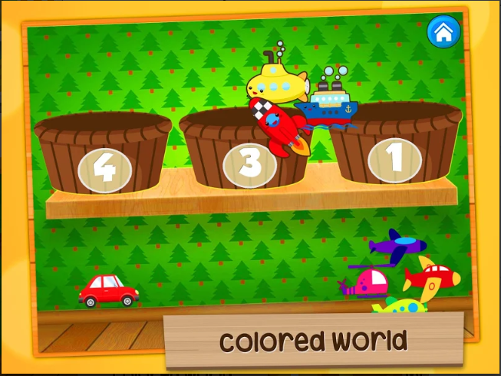

Fig 3 T&B Screenshot3

The size of this game is 20MB. The total number of users for this game has exceeded 1000000.The latest version of the game is 3.5 and this game is only supported by the android devices with an android version of 4.0.3 and above. The application is offered by AppQuiz.

### Masha and the Bear: Goodnight (Educational Game) (EduJoy, 2018)

This is another app developed by the Edujoy groups, offered by AppQuiz. This game displays the wonderful world of Masha and the bear. This game is based on the popular series of Masha, a girl whose friends are a bunch of wild animals like a bear, tiger, hare, penguin, wolf, etc.

The game is categorized into 6 different parts, as follows:

* PAINT AND COLOR: Interactive drawings for kids to improve their drawing and color identifying skills.
* WORD SEARCH: This helps the kids to study different words in different language, which indeed is an effective way to interact with the children.
* MEMORIZE OBJECTS AND SILHOUETTES: To increase the memory and improve the visual perceptions of the children, this was created.
* SOLVE PUZZLES: It consists of puzzles with large pieces of the cartoon series characters.
* MUSIC AND INSTRUNMENTS: This game helps the kids to showcase their talents in music by playing xylophone, piano or the drums.
* SIMPLE NUMBERS AND OPERATIONS: This helps the kids to learn numbers from 1 to 10.

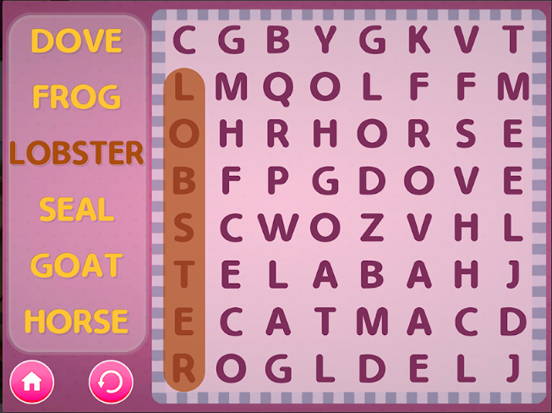

Fig 4 M&B Screenshot1

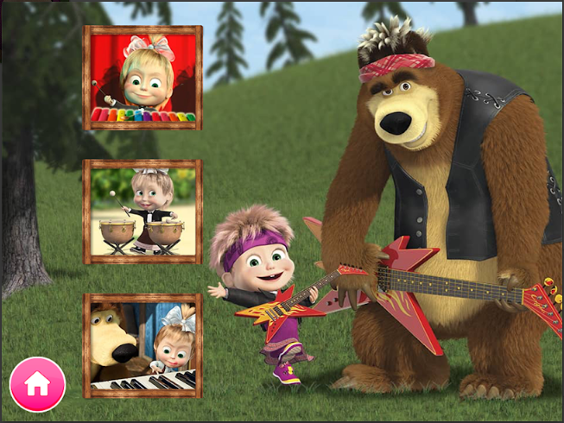

Fig 5 M&B Screenshot2

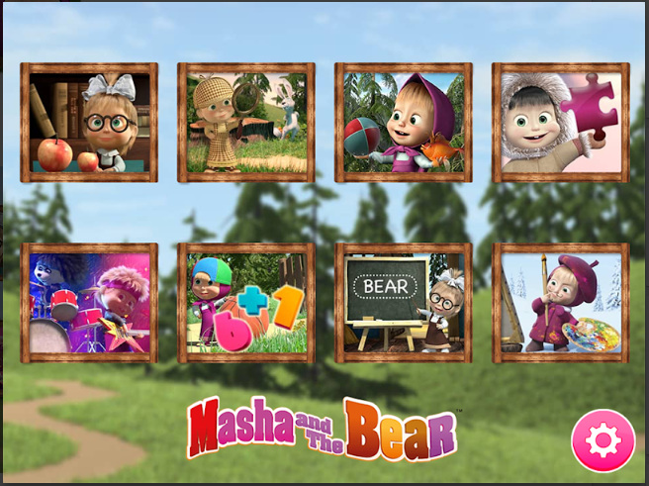

Fig 6 M&B Screenshot3

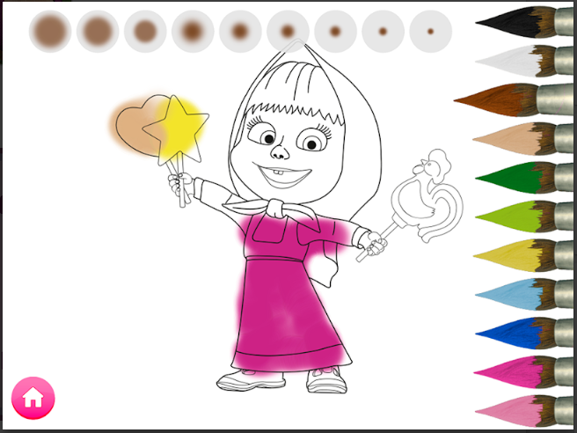

Fig 7 M&B Screenshot4

### Baby Puzzles (EduJoy, 2018)

One of the favorite games for kids that came across the Google play Store was the baby puzzles. This game keeps babies entertained with interactive sound effects. This game is easily handled and hence keeps the kids busy all the time. This game helps the babies to learn numbers, alphabets, animals, vehicles and various other stuffs like musical instruments, colors and emotions. This game is designed as an educational interface for kids and the teachers. This is a great game for testing a child's imagination skills. It also improves the concentration, memory, creativity and imagination. It also increases their observation skills and cognitive ability. This game also improves a child's coordination and speed response, hence enhancing their visual ability to observe attractive objects. This is simple and convenient. This is easy to operate, suitable for children and elderly family members. This game improves the level of practical education or social skills.

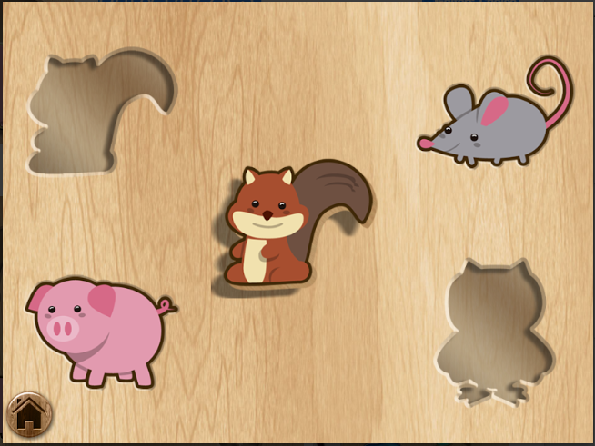

Fig 8 Baby Puzzles Image1

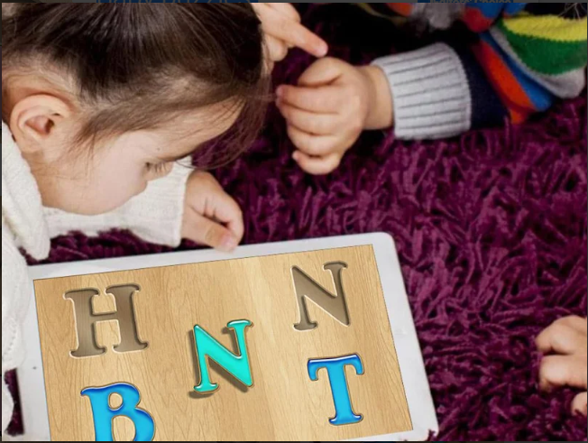

Fig 9 Baby Puzzles Image2

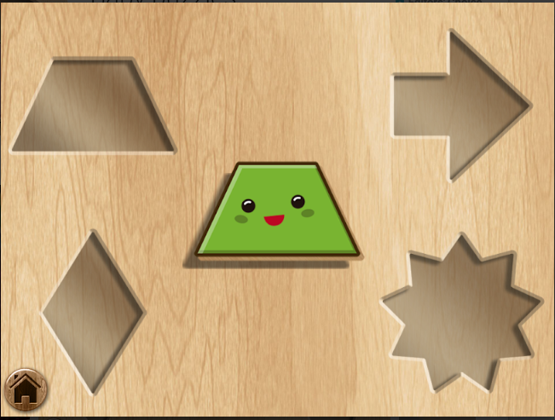

Fig 10 Baby Puzzles Image3



Fig 11 Baby Puzzles Image4

### Safety for Kid (Mage Studio)

An incident may occur any time in our life. It’s obvious to expect an accident any time in our life. So prevention is always a better option than cure. This may happen without any presumption. This game is actually a book of safety precautions. It’s a game that helps the kids to be precautious about different dangers that may occur to them in a routine life. Safety Games has brought forward an awesome game for the kids under the age of 8 years and above 3 years to know the escape routes form various hazards such as robbers, electric shock, earth quakes, lift trouble, tsunami, getting lost, strangers visit and so on. They started the game as a series to provide the tips and knowledge.

This game has been structured in such a way that the kids could improve their focus on motivational learning, building their skills, attractive environment of graphics, in-short this game contains a lot of incredible items that could impress the users. The main highlight of this game is that the contents of this game has been verified and certified by safety specialists and Australian government safety. There 12 safety lessons in this games, any situation may happen at home or shop or on streets. Learn lessons to be safe.

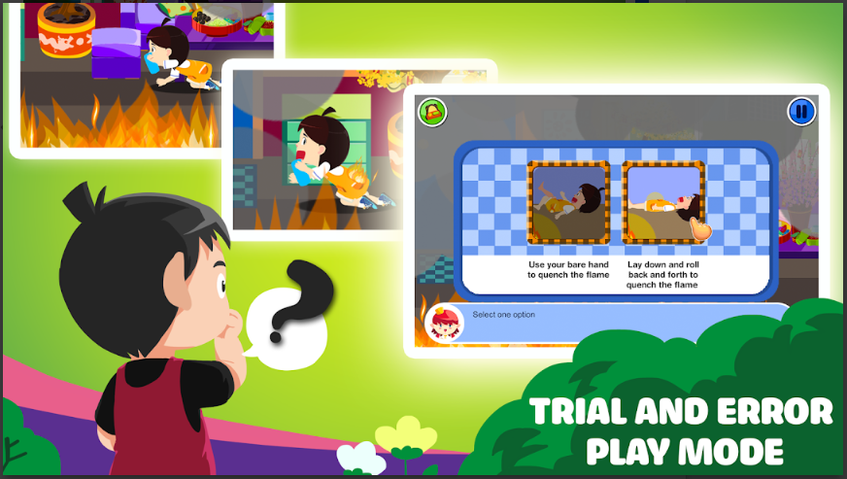

Fig 12 SafetyForKid 1

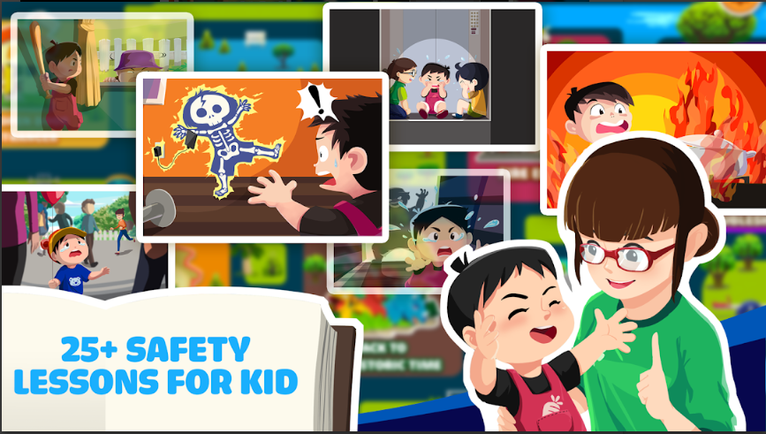

Fig 13 SafetyForKid2

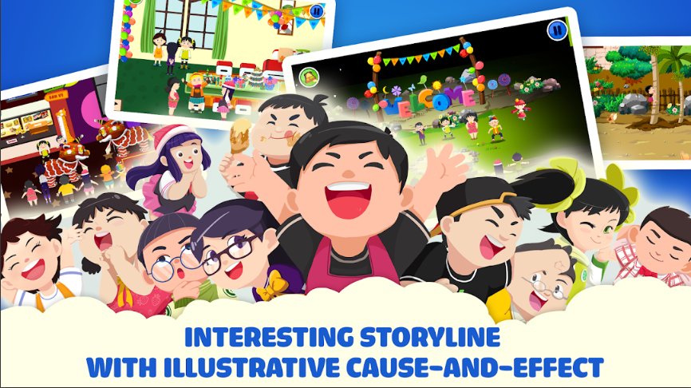

Fig 14 SafetyForKid3

### Kids Road Safety Guide: Street walking training (FROS studios, 2018)

It is very important to learn the basic life safety techniques, especially the kids. FROS studios have come up with this idea in order to make the kids aware about the safety rules to be followed when in roads or streets. This game is mainly a bunch of rules for making the kids learn how to cross the roads and various other rules. These rules incudes:

* Don’t play on the roads: This is a game that allows the child to understand the importance of playing on playgrounds or home, rather than playing in roads, as the roads are for vehicles. This may also cause accidents.
* Don’t cross road using hands free: This teaches the children to cross the road without hands free and never use any electronic devices while crossing roads.
* Use Zebra crossing to cross the roads: Use the Zebra crossing to cross the roads, this game helps to understand the importance of zebra cross.
* Follow Traffic Signals: This helps to understand the importance of the three lights in the traffic signal, when to walk, when to drive, when to stop.
* Try to use bridges: The importance of using bridges besides the roads, so that they are still sasfe from the vehicles.

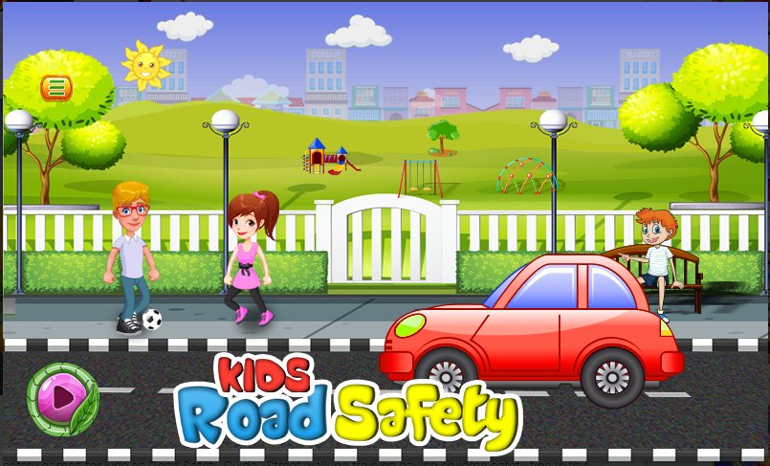

Fig 15 KidsRoadSafety1

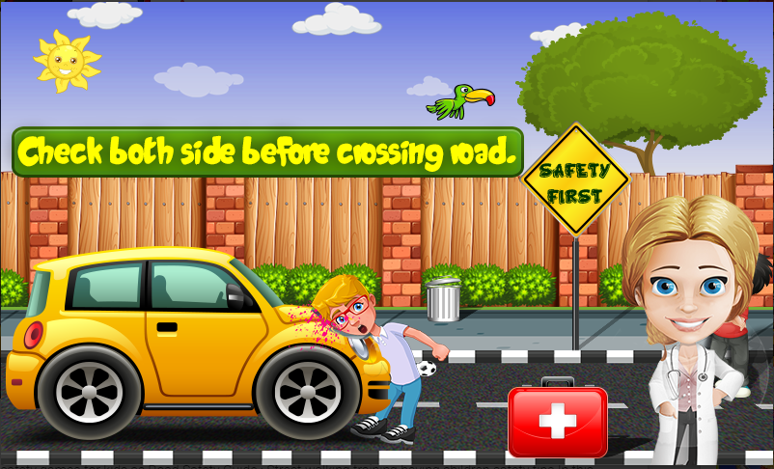

Fig 16 KidsRoadSafety2

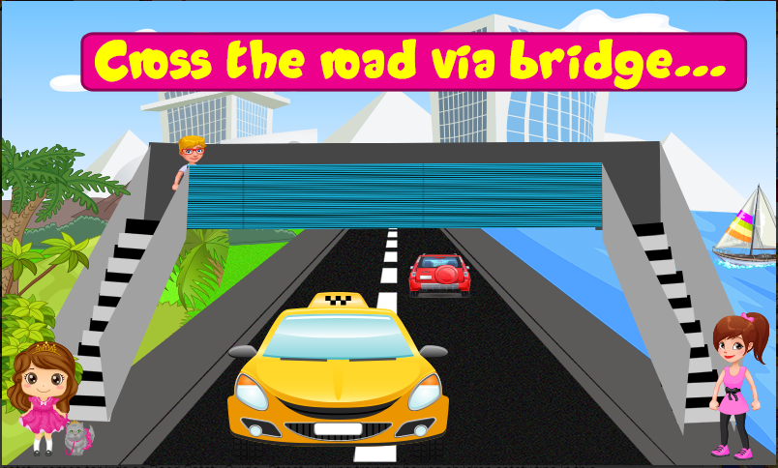

Fig 17 KidsRoadSafety3

## EXISTING APPLICATIONS: PROS AND CONS

Apart from these applications, there are a lot of games and applications that create awareness amongst the kids. These are the applications that we could gather information about, within a small time span. All these games have a lot of pros and a few cons at the same time. The following are the uses of these games:

* Advantages:
  + These games help the kids to improve their perspective visualization skills.
  + It helps to learn a lot of moral lessons for the kids.
  + It improves their knowledge of how safe and secure they must be in various situations.
  + All these games have a wide range of interactive sub-games in it.
  + These are all very interactive games.
  + Each sub game helps to build different skills of the kids.
  + This makes the works of parents and teachers, to teach the kids, easier.
* Disadvantages:
  + Most of these games are for the kids above the years of 8.
  + The games which are really for the kids between 4 years and 6 years lack in clarity.
  + These games concentrate in various themes and topics, hence making it a bit complex for the kids to remember all the safety lessons. These are the drawbacks of the games that were created to spread awareness.
  + Other games were busy in keeping the babies or kids equipped with just entertainment stuffs. These games never had an intention of providing any safety awareness.

Our main motive of creating this game is that, we are creating this game with an interactive environment and also will be loaded with many joyful sub-games. Apart from this our game also concentrates in creating awareness about the misuse of electricity and the risks caused by it. Not many games are created based on this concept. This could be a life changing option for us if this game is delivered in the way that we actually design. Our idea of gaming is inspired from the famous TV show Dora – The Explorer. Our game would be with different stages and will be finding the solutions just like finding the missing piece, only difference we would be the missing piece here would be like a puzzle, a solution and even marking the spots or numbers to complete a diagram. All the levels or sub games here would be designed in such a way that each produces an ethical moral about the awareness of how to reduce the risks caused by the misuse of electricity.

## SOFTWARE AND RESEARCH METHODOLOGY

### Spiral Technology: (Wikipedia, 2001) (Rouse, 2006)

The modern gaming methods have changed to multiple forms, these involves in our basic living style or has become a valuable part of our daily life. Almost all the gaming technology has many common characteristics such as high interaction, set of rules to be followed, fun and competitive factors. One of the most commonly used technologies in the game development is Spiral Technology. It is an SDLC (Systems Development Life Cycle) that combines the prototype technology and the waterfall model. This type of method is most commonly used in big projects with a high budget and also when it is complicated. In this methodology, an initial design is created before the development, with this design a prototype is formed with the help of this initial design. This determines the blue print of the end product. Various steps are followed after this procedure. They are:

* + - Rating the initial prototype on the basis of its strengths, weakness and the risks.
    - Explaining the necessities of the prototype followed by the initial prototype i.e. second prototype
    - Designing the second prototype with a suitable plan.
    - Building the second prototype.
    - Testing this prototype.

Once these steps are finisher, then we start to take survey with few of our customers about a few details of our project, in this manner we could get a brief idea whether we need to quit the project, according to the level of its risk scale. If the risk seems to be too high then it would be better to abort the task. Another benefit of this step is that whenever we discuss the ideas with the customers we could gather vast information about the budget and satisfaction to the customer at the end. Now we compare the current product with an existing product and rate the satisfaction of the customer. Meanwhile while rating the product if the customer comes up with any additional changes, then it is very important to look into it and if the changes are possible then it is mandatory to apply the changes if needed. Now once the whole product comes to the stream, it is kept on upgraded in every once in a while since the technology keeps on changing and is not stable. Hence it is very important for our product to be flexible and adaptable to any environment.



Fig: Spiral Model

# 4 Resources

## 4.1 Android Studio

Android Development for Google’s operating system is designed in Android Studio’s IDE (“Integrated Development Environment”). The android studio is the replaced form of ADT. The latest version of android studio is 3.2.1 and released in 2018 October. The latest stable Android studio has lot of features which is helpful for the full development of Application. (Android Studio, n.d) Some of the features are as follows:

* Quick fixes and refactoring
* Templates wizards are for creation of Android Design.
* “Android Wear” application can be build.
* For Debugging Application, “Android Virtual Device” is present.
* Layout Editor which is used to view layout on various screen.

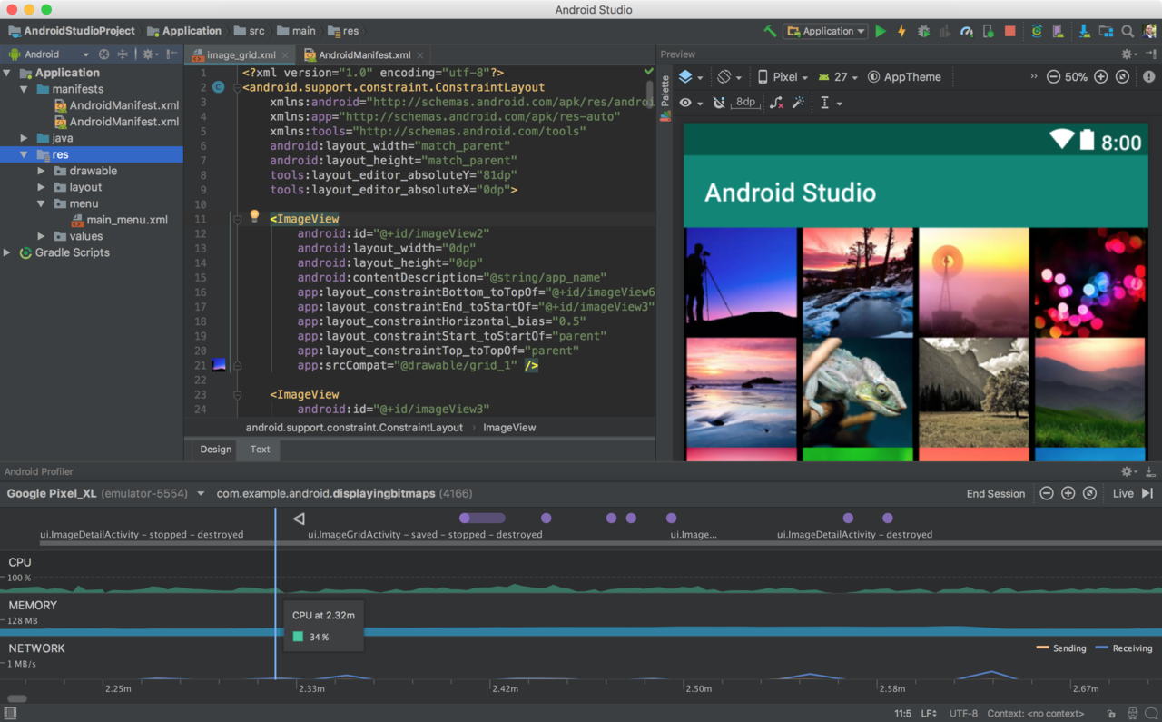

Fig 18 Android Studio (Android Studio 3.1, 2018)

## 4.2 Unity

It is the Multi - Platform Video game engine introduced by “Unity Technologies”. It is used to develop both two dimensional and three dimensional video games. There are lot of version released and the latest version is “Unity 2018.2.13” and published on 2018 October 18. The Unity is written in C++ for runtime and C# for unit scripting. It can be used in Windows and mac OS platform. Linux platform is in experimental stage. (Unity_(game_engine), n.d)



Fig 19 Unity (Unity Logo, n.d)

## 4.3 Java - Eclipse

Eclipse is IDE, operating in computer programming and commonly operating in Java IDE. Eclipse contains plugin system and base workspace for modifying the environment. Java application development is the primary use of Eclipse and other programming languages are also used to create applications. The stable version of Eclipse is 4.9(2018-09-R) and released in 2018 September. It can be used in Windows, Linux, mac OS, and Solaris. (Eclipse_(software), n.d).

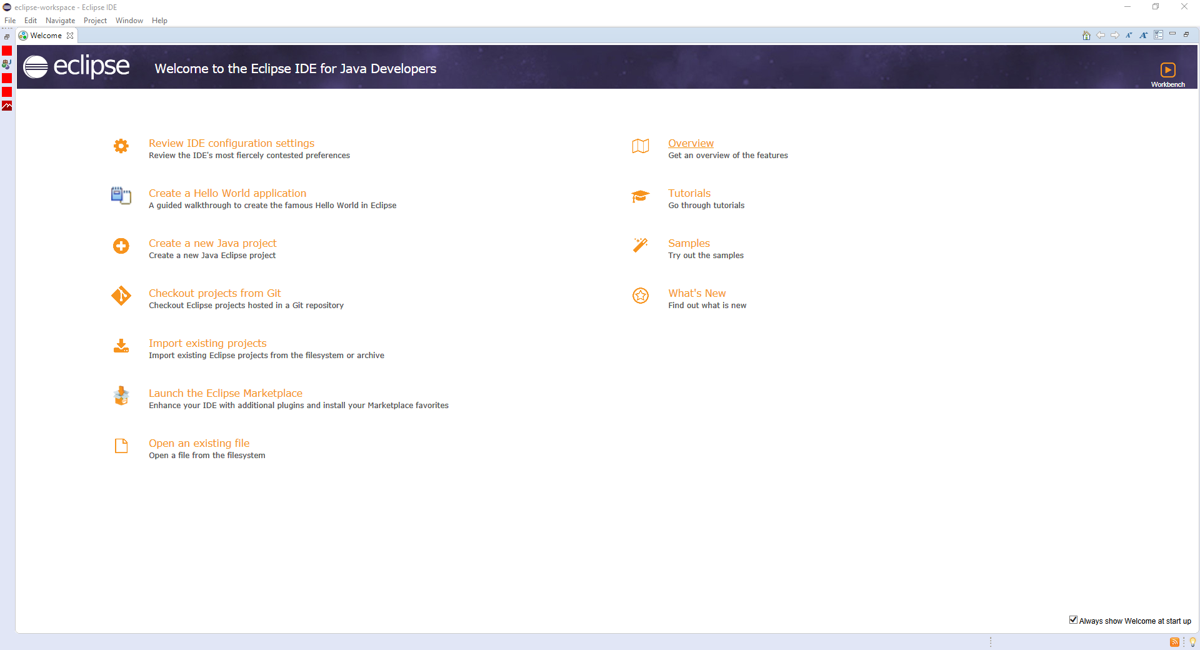

Fig 20 Eclipse (Eclipse Software 4.9, 2018)

# 5 Project Risk

Project risk contains both internal risks which related with fully completion of project in each stage, in addition to that there is external risk also. This project contains several risks, which should be managed at each stage of the project to get the project output within deadline.

## 5.1 Schedule Risk and Time Management

The schedule risk activities take longer than we expected. The overall gaming application project is planned to complete within eight weeks, but this project time is not enough for us to complete the project because, we both are from different background and doing a combined project for the first time with fixed time period. To manage this, we planned to meet weekly in one place and discuss about the project and how to achieve the project within fixed period of time and to plan the next week project work. We also create Gantt chart, in that we put the plans details and we do the work based on that chart and it will help the completion of project within deadline. Both the Gantt chart and meeting are important parts of the project and we try to do the things as per the plan for the successful completion of the project.

## 5.2 Performance Risk

Nithin and I are students and we both are from different engineering backgrounds and we have only less experience in designing, coding, testing and developing. I am from networking background and I didn’t have any idea about software area. So it’s a new experience for me. Due to that Nithin has to work more on coding and other related area and along with that he has to explain everything to me. Due to my less knowledge in application filed, error will come and he has to spend more time in rectifying that error. Even Nithin is working on Android studio for the first time for the development of gaming application and he also has some sort of issues with that. We both are doing lot of researches and studies about application creation and our willingness to study more and our maturity will help to rectify this performance risk.

## 5.3 Scope Risk

It is very important that we have a good knowledge and understanding about our project scope. If the scope is not clear or there is misunderstanding between the group members about the scope of project, it will result in the failure of project. In our group we discussed about the project scope deeply and come to a conclusion and planned the project depends on that.

## 5.4 Communicational Risk

Lack of communication is another risk which will sometimes occur in group and finally result in the failure of project. Improper communication will create confusions between group members and create unwanted problems along with that and it will affect the scope of the project indirectly. This risk can be eliminated by proper communications through direct face to face meeting, phone and mails. To manage this risk, I and Nithin talk directly about our ideas when we meet weekly and clarify all the doubts related to our project. This risk is one of the major risk and we take this seriously.

## 5.5 Hardware and software failure

This is another external risk. Failure in hardware and software may affect the overall plan of the project. All of our work is done in computers and if any failure in device may result in losing all the works. Windows problem or hardware faulty, or software issue may occur at any time. This risk can be managed by taking the back up at every time after completion of that stage. Due to that this risk can be eliminated to some extent.

# 6 Project Planning

As a project leader I (Binby Babu), tried to divide works equally, due to that both I and Nithin can contribute their part perfectly for the overall project.

## 6.1 Responsibilities

Binby Babu is the project leader, and his responsibilities for the overall project are as follows.

1. Organise meeting with lecture and clear doubts regards to project.
2. Organise weekly meeting and take initiative for completion of work within fixed period of time.
3. Presented the Project proposal presentation.
4. Introduction, Project risk, Planning, Gantt chart and Resources part in project proposal documents.
5. Checked the Project proposal and changes applied.
6. Gantt chart.
7. Assisting Nithin in application development.

Nithin Prasannakumar is the software developer and he is dealing with following responsibilities.

1. Power point presentation for project idea presentation
2. Software and Research Methodology, comparison with existing application and conclusion in project proposal documents.
3. Choosing correct software to develop the gaming application.
4. Choose correct research methodology.
5. Coding, Testing and implementation of application and Binby Babu assist when required.

Both Binby and Nithin have equal responsibility for below tasks.

1. Update weekly meeting data.
2. Designing the application.
3. Project proposal power point presentation creation and presentation in class.
4. Completing the application within fixed time schedule.
5. Presentations.

# 7 Gantt chart

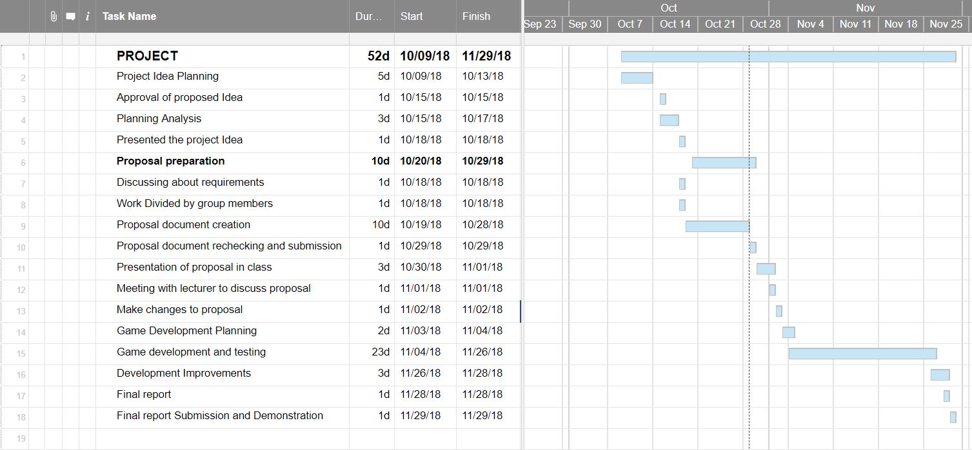

Fig 20 Gantt chart

# 8 Conclusion

We believe that by developing this game, kids may be able to learn and understand the misuse of electricity and it’s after effects. Our design as mentioned earlier is an inspiration from the cartoon show “Dora – The Explorer”. The game will be designed in such a way that there will be a main character which will be cute and adorable for the kids to get impressed. This character will be in a journey through various daily life routines, where the kid comes through various electrical mishaps. The game gives the option to select the right options to continue in order to win and earn bonuses too. If the kid choses a wrong option or end up incomplete in a level leads to the failure and would lose a ‘life’ in the game. A ‘life’ in this game is an advantage to the kids so that if they make a mistake and lose a life they can change and correct the mistakes and they can proceed to next level. Hence it keeps the kids occupied. Thereby without any boring theoretical classes or lectures, children can learn the awareness of misuse of electricity and its risks through a game. So this helps in learning and understanding too, which makes the life of children, teachers, parents and many others easy.

# 8 References

*Android Studio 3.1*. (2018, May 13). Retrieved October 26, 2018, from https://en.wikipedia.org/wiki/Android_Studio#/media/: https://en.wikipedia.org/wiki/Android_Studio#/media/File:Android_studio_3_1_screenshot.png

*Eclipse Software 4.9*. (2018, October 25). Retrieved October 26, 2018, from https://en.wikipedia.org/wiki/Eclipse_(software)#/media/File:Eclipse_4.9_Windows_10.PNG: https://en.wikipedia.org/wiki/Eclipse_(software)#/media/File:Eclipse_4.9_Windows_10.PNG

*Electricity*. (2018, October 26). Retrieved October 20, 2018, from https://en.wikipedia.org/wiki/: https://en.wikipedia.org/wiki/Electricity

EduJoy. (2018). Baby puzzles. Retrieved 10 27, 2018, from http://edujoy.es/: https://play.google.com/store/apps/details?id=com.edujoy.Baby_puzzles&hl=en

FROS studios. (2018). https://conviersolutions.com/. Retrieved 10 29, 2018, from convier solutions: https://play.google.com/store/apps/details?id=com.frosstudio.kidsroadsafety

Huwaida, M. R. (2018). Awareness about electrical consumption. *Daily Oulook*.

Jim Steyer. (n.d.). Common Sense. Retrieved 10 27, 2018, from www.commonsensemedia.org: https://www.commonsensemedia.org/app-reviews/peek-a-zoo-by-duck-duck-moose

Karachi, S. A. (2012, November 08). *Use and Misuse of electricty*. Retrieved October 2018, 20, from https://www.dawn.com/: https://www.dawn.com/news/762348

Mage Studio. (n.d.). kynangchobe. Retrieved 10 29, 2018, from kynangchobe.vn: https://play.google.com/store/apps/details?id=com.bluebirdaward.survivalskill

Peta Daniels. (2012). safety4kids. Retrieved 10 27, 2018, from https://www.safety4kids.com: https://www.safety4kids.com.au/safety-zone_stranger-danger

*Android Studio*. (n.d). Retrieved October 2018, 26, from https://en.wikipedia.org/wiki/: https://en.wikipedia.org/wiki/Android_Studio

*BC hydro power smart*. (n.d, n.d n.d). Retrieved October 2018, 21, from https://www.bchydro.com/: https://www.bchydro.com/safety-outages/electrical-safety/safety-at-home/safety-for-kids.html

*Eclipse_(software)*. (n.d, n.d n.d). Retrieved October 26, 2018, from www.eclipse.org: https://en.wikipedia.org/wiki/Eclipse_(software)

*Electricity Authority*. (n.d, n.d n.d). Retrieved October 2018, 20, from https://www.ea.govt.nz/consumers/: https://www.ea.govt.nz/consumers/what-is-electricity/

*Healthy safe and productive lives*. (n.d, n.d n.d). Retrieved October 2018, 20, from https://www.hsa.ie/: https://www.hsa.ie/eng/Topics/Electricity/Dangers_of_Electricity/

*Unity Logo*. (n.d, n.d n.d). Retrieved October 26, 2018, from https://www.google.co.nz/search?q=unity&source=lnms&tbm=isch&sa=X&ved=0ahUKEwjEr53Xg6reAhUS4o8KHTCbDuoQ_AUIDigB&biw=1536&bih=706#imgrc=vSKEXkqvV_wlLM:: https://www.google.co.nz/search?q=unity&source=lnms&tbm=isch&sa=X&ved=0ahUKEwjEr53Xg6reAhUS4o8KHTCbDuoQ_AUIDigB&biw=1536&bih=706#imgrc=vSKEXkqvV_wlLM:

Rouse, M. (2006). search software Quality. Retrieved 10 29, 2018, from searchsoftwarequality.techtarget.com: https://searchsoftwarequality.techtarget.com/definition/spiral-model

Wikipedia. (2001). Wikipedia. Retrieved 10 29, 2018, from www.wikipedia.com: https://en.wikipedia.org/wiki/Spiral_model#/media/File:Spiral_model_(Boehm,_1988).svg

EduJoy. (2018). Baby puzzles. Retrieved 10 27, 2018, from http://edujoy.es/: https://play.google.com/store/apps/details?id=com.edujoy.masha.games

*Unity_(game_engine)*. (n.d, n.d n.d). Retrieved October 26, 2018, from https://en.wikipedia.org/wiki/: https://en.wikipedia.org/wiki/Unity_(game_engine)